**JavaScript - Tutorial**

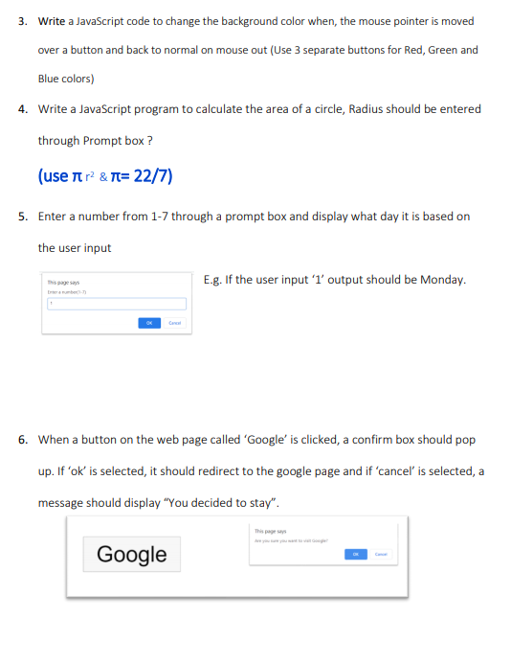03)

<!DOCTYPE html>

<html>

<head>

<title>Background Color Changer</title>

</head>

<body>

<h1>Move the mouse pointer over the buttons to change the background color</h1>

<button onmouseover="changeBackgroundColor('red')" onmouseout="resetBackgroundColor()">Red</button>

<button onmouseover="changeBackgroundColor('green')" onmouseout="resetBackgroundColor()">Green</button>

<button onmouseover="changeBackgroundColor('blue')" onmouseout="resetBackgroundColor()">Blue</button>

<script>

function changeBackgroundColor(color) {

document.body.style.backgroundColor = color;

}

function resetBackgroundColor() {

document.body.style.backgroundColor = "white";

}

</script>

</body>

</html>

04)

<!DOCTYPE html>

<html>

<head>

<title>Circle Area Calculator</title>

</head>

<body>

<h1>Circle Area Calculator</h1>

<button onclick="calculateArea()">Calculate Area</button>

<script>

function calculateArea() {

const radius = parseFloat(prompt("Enter the radius of the circle:"));

if (isNaN(radius)) {

alert("Invalid input. Please enter a valid number for the radius.");

return;

}

const area = Math.PI * Math.pow(radius, 2);

alert(`The area of the circle is: ${area.toFixed(2)}`);

}

</script>

</body>

</html>